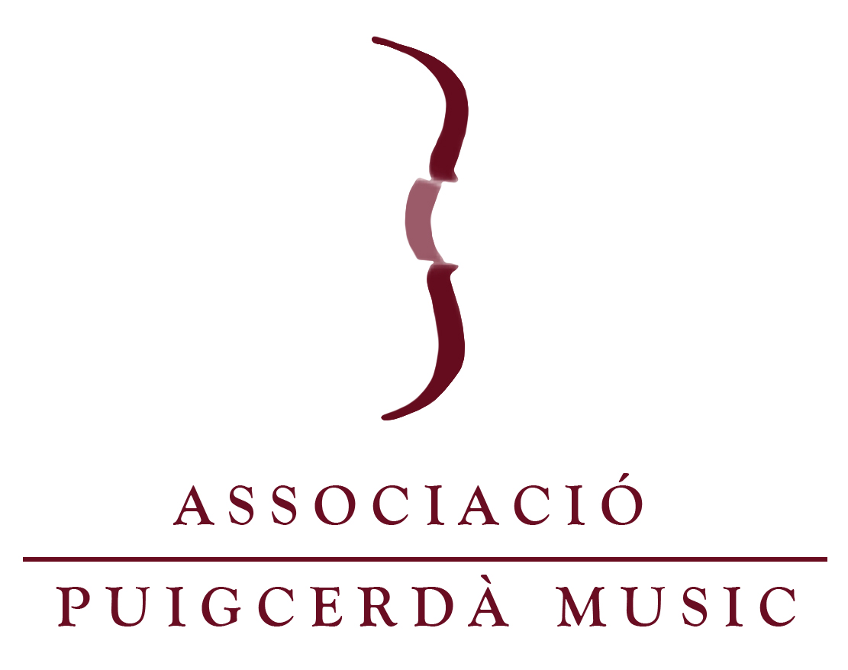

Puigcerda Music Festival Master Class
AUTHORIZATION FORM FOR MINORS

I, _________________with DNI/Passport Number: ____________mother/father of Student_________________, give my son/daughter the authorization to participate in the Puigcerda Music Festival Master Class 2022, and accept that the course does not provide any underage supervision of minors, and I am responsible for the arrangements of underage supervision.

First Name: Last Name:
Date:
Signature:

